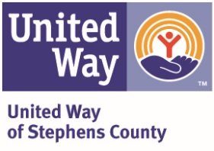
Day of Caring 2022
Project Information Sheet

Yes, we will participate: ______ No, we will not participate: ______

Agency name: ___________________________________________________________

Your Project Coordinator: ______________________________

Cell Number: __________________

Project address: _________________________________________________________

Project Summary (please be a specific as possible):____________________________

________________________________________________________________________

________________________________________________________________________

________________________________________________________________________

________________________________________________________________________

Number of volunteers needed: _____________________________________________

Do you have a vehicle available to haul away items to the dump? ______

PLEASE NOTE:
Projects will be considered based on the scope of the request and the ability of volunteers to complete the project during the given time frame (May 13th, 9am – 4pm). Projects are subject to State licensing requirements and regulations; as well as availability of certified volunteers.

Deadline for project request submission is April 11th. Requests submitted after the deadline WILL NOT be considered for inclusion.

You must assign your own project leader for your project. The project leader must remain on site to offer advice to all volunteers. All prep work needed for your project must be done prior to volunteers arriving on that day. (ie. if you requested a room be painted, please prep walls by removing hanging items and nails, covering holes, cleaning walls, etc.)

United Way of Stephens County will contact donors for materials, you do not need to do so.

Please complete this form and email to assistant@unitedwayofsc.org, or hstewart@unitedwayofsc.org or mail to P.O. Box 1632, Duncan OK 73534 no later than April 12, 2021.

